Java Jenkins Docker Tutorial
This repository contains a minimal Java application designed to demonstrate a complete CI/CD workflow using Jenkins, Maven, Docker, and Docker Compose.

📖 Overview
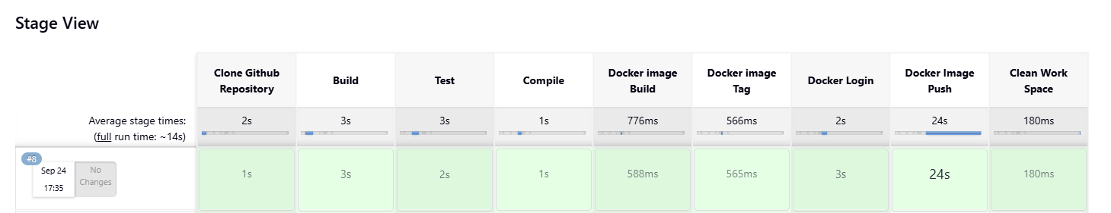
This project is intended for beginners who want to learn:
- How to create a simple Java application
- How to build, compile, and test it using Maven
- How to containerize it with Docker
- How to run it using Docker Compose
- How to automate the entire workflow using a Jenkins pipeline
The application itself is a simple Java "Hello World" program with a basic JUnit test.

📂 Project Structure
java-jenkins-docker/
│── src/
│ ├── main/java/com/example/App.java # Main Java Application
│ └── test/java/com/example/AppTest.java # Unit Tests (JUnit)
│── pom.xml # Maven Build File
│── Dockerfile # Docker Image Definition
│── docker-compose.yml # Docker Compose Configuration
│── Jenkinsfile # Jenkins Pipeline Script
│── README.md # Project Documentation

⚙️ Build, Test, and Compile Workflow
1️⃣ Build
We use Maven to compile the Java source code:
mvn clean package
- mvn clean removes any previous build artifacts.
- mvn package compiles the code and packages it into a JAR file.
- Output JAR: target/java-jenkins-docker-1.0-SNAPSHOT.jar

2️⃣ Test
The project includes a basic JUnit test:
mvn test
This runs all tests inside the src/test/java directory.

3️⃣ Compile
Maven automatically compiles the Java source files during the package phase:
mvn compile
This ensures all Java files are translated into .class files in the target/classes directory.

🚀 Running Locally
After building the project, run the application locally:
java -jar target/java-jenkins-docker-1.0-SNAPSHOT.jar
Expected Output:
Hello from Java Application for Jenkins CI/CD!

🐳 Running with Docker
1️⃣ Build Docker image
docker build -t java-jenkins-docker:latest .
2️⃣ Run Docker container
docker run --rm java-jenkins-docker:latest

⚙ Running with Docker Compose
If you want to run the app using Docker Compose:
1️⃣ Build & run services
docker-compose up --build
2️⃣ Stop services
docker-compose down

🔄 Jenkins Pipeline
The provided Jenkinsfile automates the process:
pipeline {
agent any
stages {
stage('Build') {
steps {
sh 'mvn clean package'
}
}
stage('Test') {
steps {
sh 'mvn test'
}
}
stage('Docker Build') {
steps {
sh 'docker build -t java-jenkins-docker:latest .'
}
}
stage('Docker Run') {
steps {
sh 'docker run --rm java-jenkins-docker:latest'
}
}
}
}
Pipeline Stages:
- Build – Compiles and packages the Java code
- Test – Runs JUnit tests
- Docker Build & Run – Builds and runs the Docker image

🛠 Prerequisites
You need to have the following installed:
- Java 17+
- Apache Maven
- Docker
- Docker Compose
- Jenkins (optional for CI/CD testing)

📜 License
This project is released under the MIT License.

